At St. Werburgh’s, we define spirituality through four key words/areas and facilitate the development if these through our ambitious curriculum, which is an extension of our vision, ‘Life in all its fullness’. Just like a tree, we believe spirituality can grow and develop over time and as we nurture spiritual development of all stakeholders in our school community, we know they will benefit from the fruit of this in the future.
 | Reflection – The mirror  Mirrors – Self: Like looking in a mirror. Thinking about ourselves and how we feel about things.  Spirituality is about Reflection, this encourages our school community to spend time reflecting on themselves, their thoughts, beliefs, values and feelings. It gives them space to ask questions about themselves.
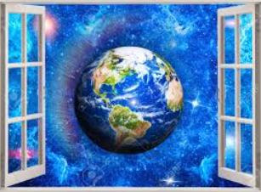 | Experience – The Window  Window – Beauty: Like looking through a window. Looking at the world in new ways.  Spirituality is about Experience. Imagine looking out of a window at the world around us. Think about its beauty and any questions or curiosities you have. Giving our schools community space to ask questions about the world around us.
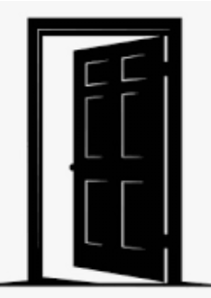 | Transformation – The door  Doors – Others: Like opening a door to welcome people in: understanding how other people will feel.  Spirituality is about Transformation. The image of the door supports our school community to think about the things that change in life when we go from one place to somewhere else. They can think about other people who might be beyond the door. What do we have in common? What is different? How can we help?
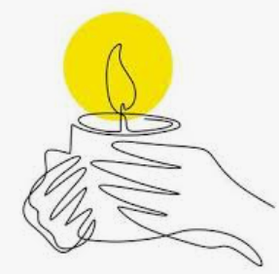 | Encounter – The candle  Candle – Beyond: Like watching a flame and thinking. Reflecting on our learning and experiences.  Spirituality is about Encounters. An awareness of the things we cannot see in life, but we can feel. For many in our community this is expressed as an awareness of God and personal faith. It is also about developing imagination.

Reflection – The mirror

Mirrors – Self:

Like looking in a mirror. Thinking about ourselves and how we feel about things.

Experience – The Window

Window – Beauty:

Like looking through a window. Looking at the world in new ways.

Transformation – The door

Doors – Others:

Like opening a door to welcome people in: understanding how other people will feel.

Encounter – The candle

Candle – Beyond:

Like watching a flame and thinking. Reflecting on our learning and experiences.

